**Procedure: -**

Follow the following steps to create an EC2 instance using Terraform :

1.Install VC Extension to support terraform coding.

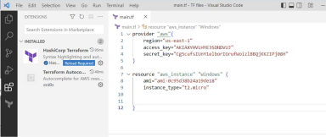2. We need to connect AWS account (for that you will require AWS Account) 3. We need to Create Users in IAM giving the EC2 access policy or the Admin Access 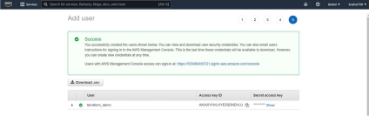4. Provide your access key and Secret key and AMI ID (Amazon Machine Image ID) 5.Ready with code to launch EC2 Instance

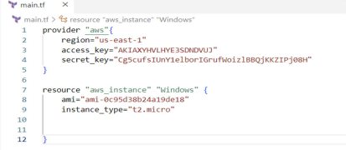

Give the following Commands in the Terminal

>> terraform init

>> terraform validate

>> terraform plan

>> terraform apply

>> terraform destroy

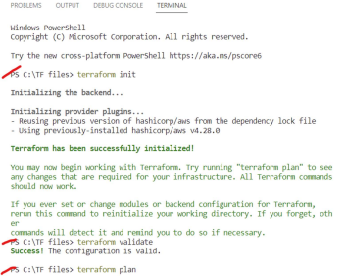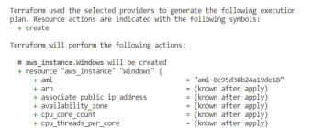

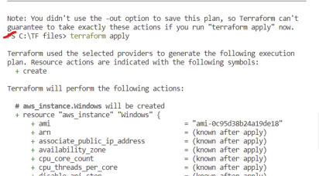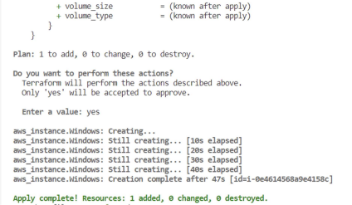

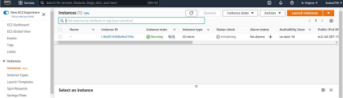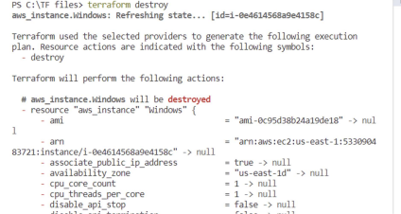

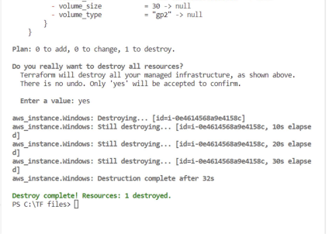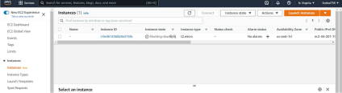

**Conclusion:-**